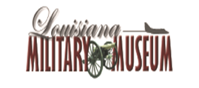
Museum Governing Board
Meeting

Monday,
December 2, 2013
6:00 pm
Public welcome

The next meeting will be in December 2014; details to be announced at a later time.

